YOUTH DEVELOPMENT COUNCIL “YDC”

Dear Parent/Guardian,

Thank you for allowing your child to be part of the YDC after-school and summer programs. YDC will offer an after-school program at William Monroe Middle School this fall. Since your child participated in YDC programming, your child is invited to participate this fall. The YDC after-school program will not only support students with their homework and reading, but will provide fun activities, community involvement, character and team building exercises. The students will meet at WMMS on Monday and Wednesday until 6 p.m. Students are required to attend both days. The program will start on September 9th and run through December 4th.

Students will need to be picked up by 6 p.m. at the WMMS cafeteria. You will be required to sign them out at the WMMS cafeteria. Please fill out the Registration form and the Parental Release form. Please return both forms to the school office by Friday August 30th. Please feel free to call me with any questions.
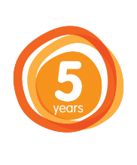

The YDC after-school program is entering its fifth year and looking forward to another great year!

Thank you!
Mike

Mike Alley
Executive Director
Youth Development Council of Greene
www.greeneyouth.org

WMMS

